Question 1
Source Code
#include <stdio.h>
#include <string.h>

struct meal{
char name[30];
float calories;
char type[20];
int costs;
};
int main(){
struct meal record[4];
for (int i = 0; i<4; ++i){
//user input

printf("%d type of food:\n",i+1);
printf("Enter the name of the food: \n");
scanf("%s", record[i].name);
//calories of food
printf("Enter the calories: \n");
scanf("%f", &record[i].calories);
//type of food
printf("Enter the type of food like meat or fruit: \n");
scanf("%s", record[i].type);
//The total cost of food
printf("cost of the food: \n");
scanf("%d", &record[i].costs);
printf("\n");
}
for (int i = 0; i < 4; ++i){
printf("Name of the food : %s\n",record[i].name);
printf("Calories of the food : %f\n",record[i].calories);
printf("Type of the food : %s\n",record[i].type);
printf("Cost of the food : %d\n",record[i].costs);
printf("\n");
}
return 0;
}
Output
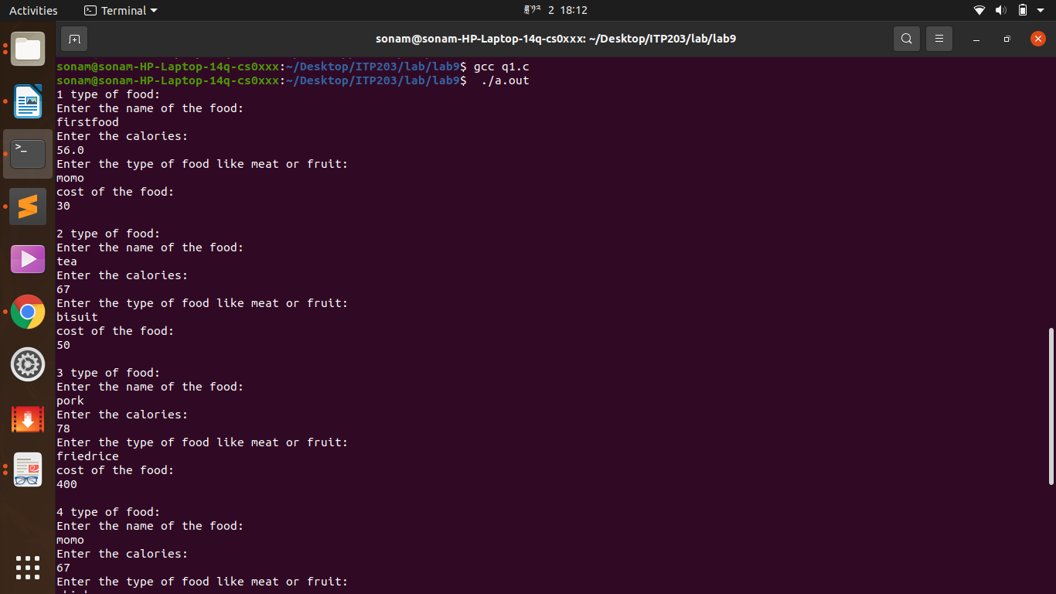
Question 2
Source Code
#include <stdio.h>
#include <string.h>
#include<stdlib.h>
struct library{
char title[20];
char name[20];
int price;
char status[10];
};
int main(){
struct library record[50];
int option;
int n;
char topic[20];
char author[20];
printf("\n");
do{
printf("Select any option from below \n");
printf("1. Adding the book \n");
printf("2. Displaying the book \n");
printf("3. Listing book of specific author \n");
printf("4. List the title of the specific book \n");
printf("5. List count of the book \n");
printf("6. Exit \n");
printf("Enter you choice: \n");
scanf("%d", &option);
switch(option){
case 1:
printf("How many books you want to add \n");
scanf("%d", &n);
for(int i = 0; i<n; i++){
printf("Enter the title of the book :\n");
scanf("%s", record[i].title);
printf("Enter the name of the author: \n");
scanf("%s", record[i].name);
printf("Enter the price of the book: \n");
scanf("%d", &record[i].price);
printf("Enter the status of the book: \n");
scanf("%s", record[i].status);
printf("\n");
printf("------Book are successfully added------\n");
printf("\n");
}
break;printf("\n");
case 2:
if(n==0){
printf("The library is empty\n");
}
else{
for (int i = 0; i < n; i++){
printf("Title of the book : %s\n",record[i].title);
printf("Name of the book : %s\n",record[i].name);
printf("Price of the book: %d\n",record[i].price);
printf("Status of the book : %s\n",record[i].status);
printf("\n");
}
}
printf("\n");
break;
printf("\n");
case 3:
printf("Enter the name of the author: ");
scanf("%s", author);
for(int i=0; i<n; i++){
if(strcmp (record[i].name, author) == 0){
printf("%s\n", record[i].title );
}
}
break;
printf("\n");
case 4:
printf("\n");
printf("Enter the title of the book:\n");
scanf("%s", topic);
printf("Details of the book\n");
for (int i = 0; i < n; ++i){
if(strcmp(record[i].title, topic)==0){
printf("Author name : %s\n",record[i].name );
printf("Price of the book : %d\n",record[i].price);
printf("Status of the book : %s\n",record[i].status );
}
}
printf("\n");
break;
printf("\n");
case 5:
printf("The number of the book is : %d\n",n );
printf("\n");
break;
case 6:
exit(0);
default:
printf("Invalid");
}
}
while(option != 6);
return 0;
}
Output
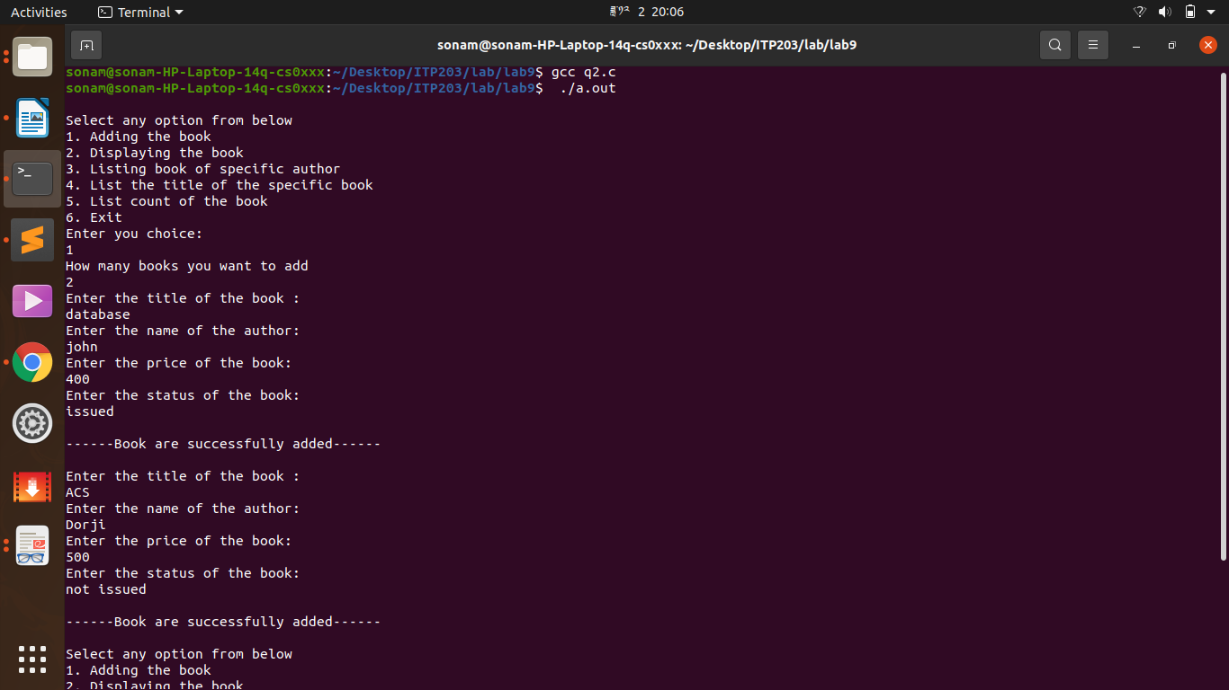

Question 3
Source Code
#include <stdio.h>
struct Hotel
{
char Name[20];
char Address[20];
int Grade;
float Room_Charges;
int Rooms;
};

int main()
{
int i, ch, grade, Price, n = 2;
struct Hotel H[20];

printf("Enter %d Numbers Of Hotels: \n", n);

for (i = 0; i < n; ++i)
{
printf("\nRecord Number %d : \n", i+1);

printf("Hotel Name: ");
scanf("%s", H[i].Name);
printf("Hotel Address: ");
scanf("%s", H[i].Address);
printf("Hotel Grade: ");
scanf("%d", &H[i].Grade);
printf("Hotel Room Charges: ");
scanf("%f", &H[i].Room_Charges);
printf("Hotal Number Of Room(s): ");
scanf("%d", &H[i].Rooms);
}

do
{
printf("\n\tMenu Of A Hotel\n\n");
printf("1. Print Out Hotels Of A Given Grade In Order Of Charges.\n");
printf("2. Print Out Hotels With Room Charges Less Than A Given Values.\n");

printf("Enter Your Choice 1-2: ");
scanf("%d", &ch);

switch(ch)
{
case 1:
printf("Enter Grade 1 To 5: ");
scanf("%d", &grade);

for (i = 0; i < n; ++i)
{
if(H[i].Grade == grade)
{
printf("\nHotel Name: %s", H[i].Name);
printf("\nHotel Grade: %d", H[i].Grade);
printf("\nHotal Room Charges: %f", H[i].Room_Charges);
printf("\n");
}
}
break;

case 2:
printf("Enter The Room Charges Of Your Choice: ");
scanf("%d", &Price);

printf("The Room Charges Less Than Your Choice: \n");

for (i = 0; i < n; ++i)
{
if(H[i].Room_Charges < Price)
{
printf("\nHotel Name: %s", H[i].Name);
printf("\nHotel Grade: %d", H[i].Grade);
printf("\nHotel Address: %s", H[i].Address);
printf("\nHotal Room Charges: %f", H[i].Room_Charges);
printf("\n");
}
}
break;

}
}while(ch != 2);

return 0;
}

OUTPUT
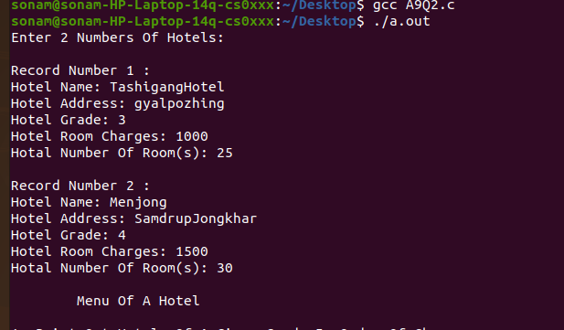

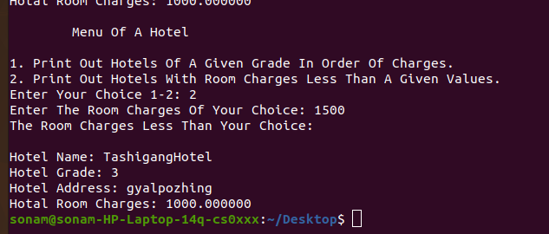

Question 4
Source Code
#include <stdio.h>

struct Distance{
int feet;
float inch;
}d1,d2, outcome;

int main(){
//take first distance user input
printf("Entered the first distance\n");
printf("Entered the feet: ");
scanf("%d",&d1.feet);
printf("Entered the inch: ");
scanf("%f",&d1.inch);

//take second distance user input
printf("Entered the second distance\n");
printf("Entered the feet: ");
scanf("%d",&d2.feet);
printf("Entered the inch: ");
scanf("%f",&d2.inch);

//adding two distance
outcome.feet = d1.feet + d2.feet;
outcome.inch = d1.inch + d2.inch;

//compute inches to feet if greater than 12
while(outcome.inch >=12.0){
outcome.inch = outcome.inch -12.0;
++outcome.feet;
}
printf("Sum of distance is = %d'-%.1f\"",outcome.feet,outcome.inch);
return 0;
}
Output
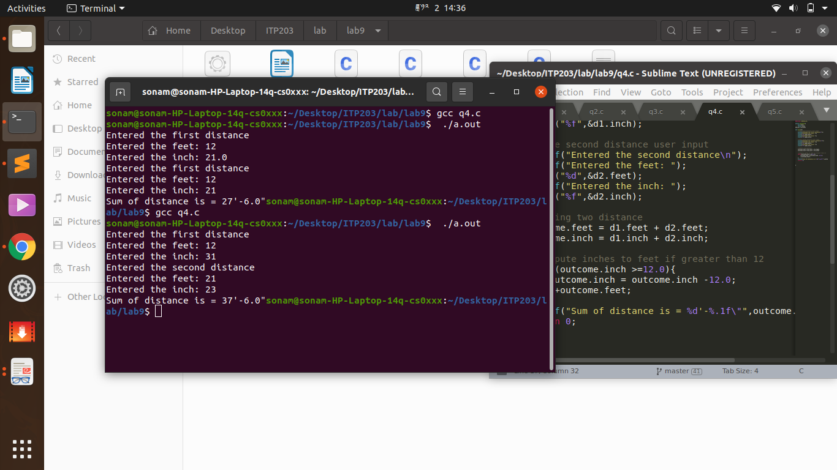

Question 5
Source Code
#include <stdio.h>
struct complex{
int real;
int img;

};
int main(){
struct complex a, b, sum;
printf("The first complex number are:\n");
printf("Enter a and b where a + ib is the first complex number.\n");
scanf("%d%d", &a.real, &a.img);
printf("The second complex number are\n");
printf("Enter sum and d where sum + id is the second complex number.\n");
scanf("%d%d", &b.real, &b.img);

sum.real = a.real + b.real;
sum.img = a.img + b.img;

printf("Sum of the complex numbers: (%d) + (%di)\n", sum.real, sum.img);

return 0;
}

Output
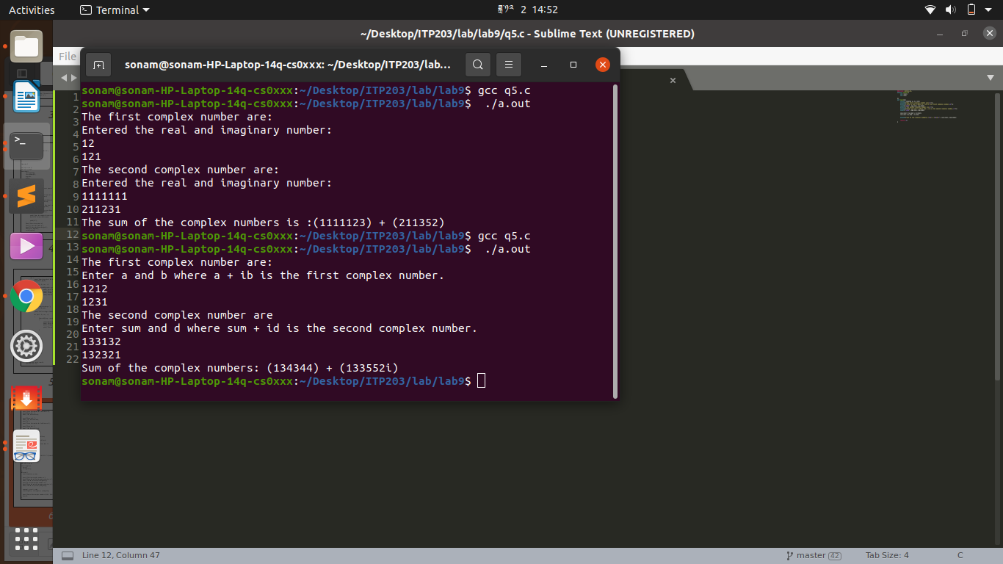

submiited by sonam choki
group B
12190079

